IdeationPhase
Brainstorm & Idea Prioritization Template
Date | 3 Feb 2026
Team ID | LTVIP2026TMIDS60231
Project name | ToyCraft Tales: Tableau's Vision into Toy  Manufacturer Data
Maximum Marks | 4 Marks
Brainstorm & Idea Prioritization Template:

Brainstorming provides a free and open environment that encourages everyone within a team to participate in the creative thinking process that leads to problem solving. Prioritizing volume over value, out-of-the-box ideas are welcome and built upon, and all participants are encouraged to collaborate, helping each other develop a rich amount of creative solutions.
Use this template in your own brainstorming sessions so your team can unleash their imagination and start shaping concepts even if you're not sitting in the same room.
In this project,our team of five data analysts set out to explore how toy products perform—from factory to store shelf—using Tableau dashboards.
We focused on two key questions:
- How do toy categories perform across regions and time?
- What trends in sales and operations can help improve efficiency?
The dataset included details like product categories, customer types, regional sales, purchase dates, and inventory data.
We began with a brainstorming session where each member shared ideas. We then grouped and prioritized them based on complexity, effort, and impact. This helped us focus on the most valuable insights and assign tasks based on team strengths.
The outcome: a set of clear, interactive dashboards that tell the ToyCraft story through data— helping make smarter decisions for the business.
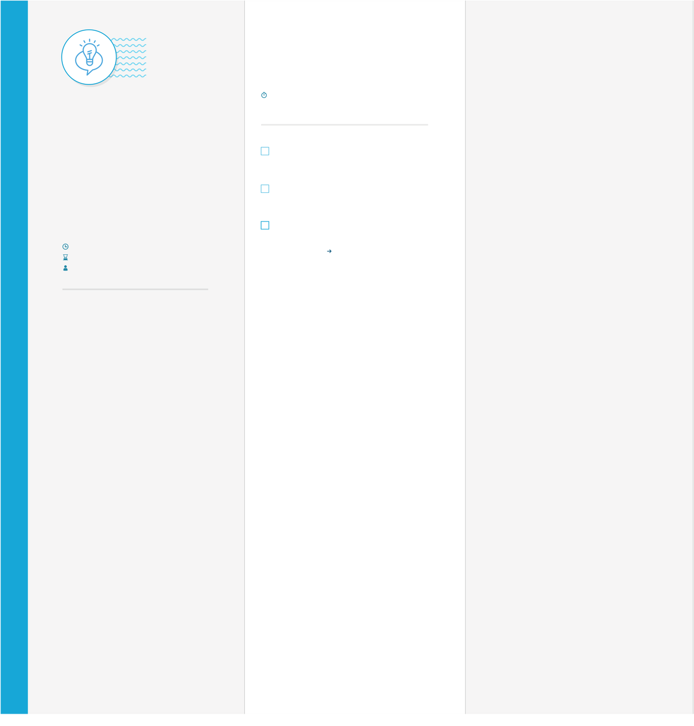

Step-1: Team Gathering, Collaboration and Select the Problem Statement
Brainstorm
&
idea prioritization
Use this template in your own
brainstorming sessions so your team
can unleash their imagination and
start shaping concepts even if you
'
re
not sitting in the same room
.
minutes
10
to prepare
hour
1
to collaborate
2
-
8
people
recommended
T
e
m
p
l
a
t
e
Learn how to use the facilitation tools
Use the Facilitation Superpowers to run a happy and
s
productive se
s
ion
.
Set the goal
Think about the problem you
'
ll be focusing on solving in
the brainstorming session
.
Team gathering
Define who should participate in the session and send an
invite
.
Share relevant information or pre
-
work ahead
.
Stay in topic
.
Go for volume
.
Defer judgment
.
To run an smooth and productive session
Listen to others
.
If possible
,
be visual
.
Encourage wild ideas
.
C
A
B
PROBLEM
Before you collaborate
A little bit of preparation goes along way

Define your problem statement

with this session
.
Here
’
s what you need
to do to get going
.
What problem are youtrying tosolve
?
Frame your
problem as a How Might We statement
.
This will be the
focus of your brainstorm
.
10
minutes
5
minutes
Open article
Key rules of brainstorming
1
How might we help ToyCraft better understand

and improve toy

sales performance across regions and

time using clear
,

interactive Tableau visualizations
?
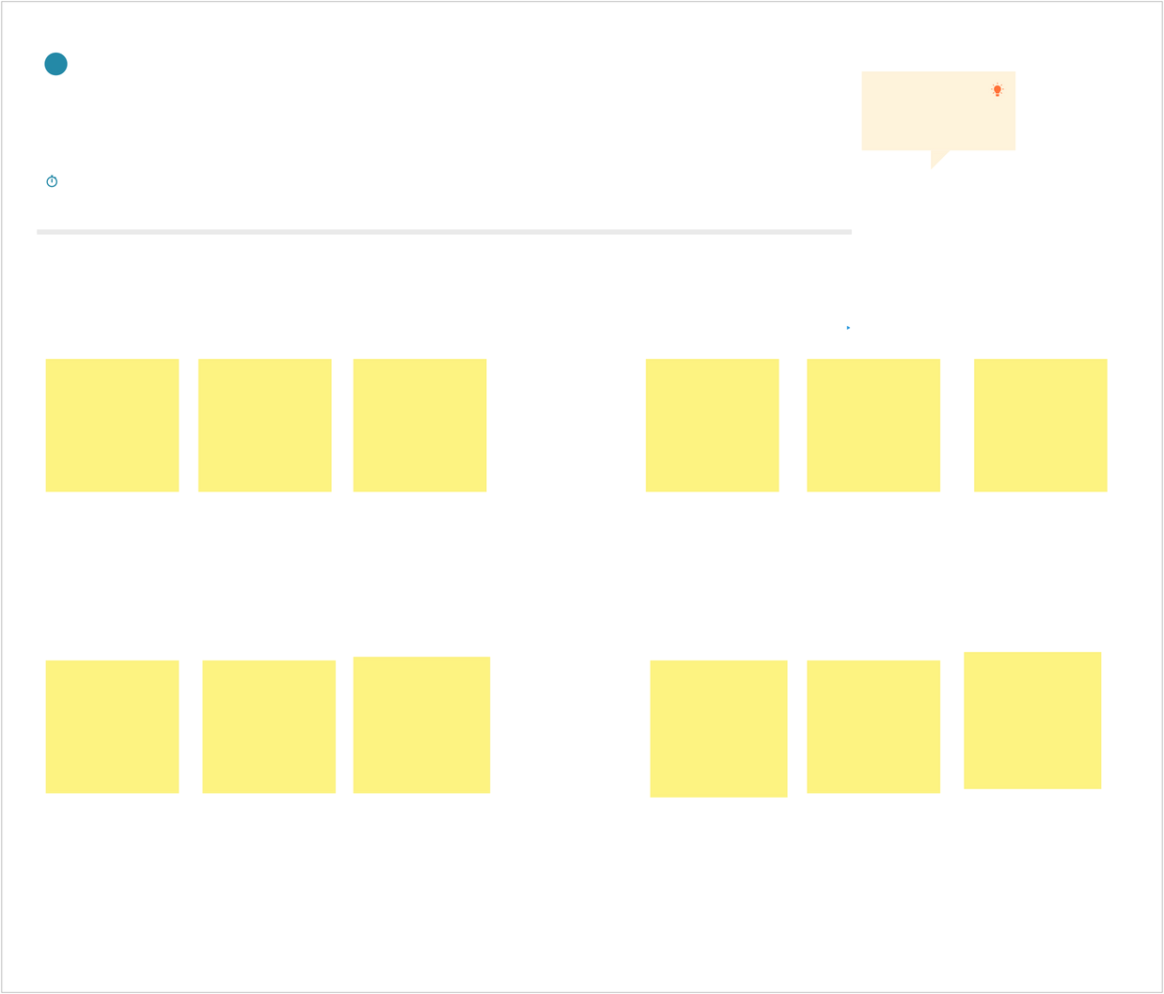
Step-2: Brainstorm, Idea Listing and Grouping
Brainstorm
Write down anyideas that come to mind

that address your problem statement
.
10
minutes
2
TIP
You can select a sticky note
and hit the pencil
[
switch to
sketch
]
icon to start drawing
!

Kavya

Dispalying
gender wise
customer
preferences
Compare
branch
-
wise
sales across
cities
Tracks best
-
selling toy
types by age
group

Age group
targeting
Displaying
sales by
price ranges
Monika
Identify
seasonal
spikes in toy
sales
Visualize
repeat
purchase
patterns
Spot
overstock
and
understock
issues
Analyze
seasonal
trends in
toy demand
Track
inventory
turnover
rate
Displays best
-
selling toys and
top
-
performing
distribution hubs
Understanding
customer
satisfaction
through ratings
and reviews
Keerthi priya

venkata Saranya
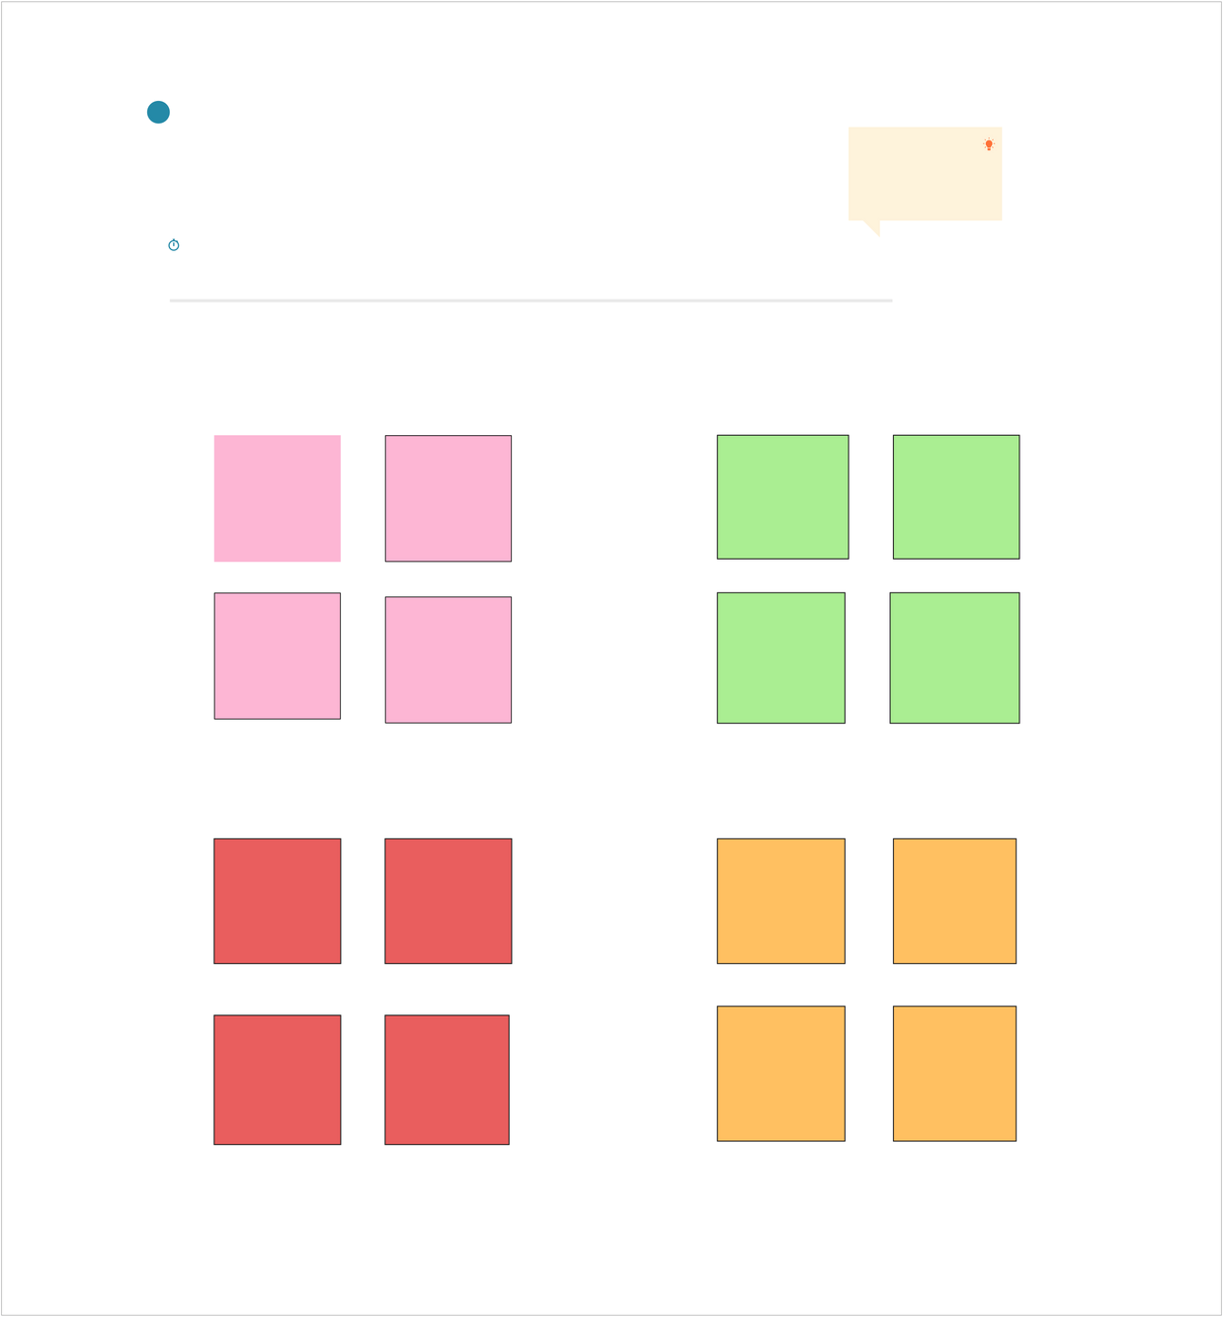
Group ideas
Take turns sharing your ideas while clustering similar or related notes as you go
.
Once all
sticky notes have been grouped
,
give each cluster a sentence
-
like label
.
If a cluster is
bigger than six sticky notes
,
try and see if you and break it up into smaller sub
-
groups
.
minutes
20
3
TIP
Add customizable tags to sticky
notes to make it easier to find
,
browse
,
organize
,
and
categorize important ideas as
themes within your mural
.
Displaying
best
-
selling
toys

Compare best
sellers month
over month
Highlight
products with
high sales during
holidays and
special
Group best
-
selling toys
based on target
age range
Insights into top selling toys
Supplier
delivery time
analysis
stocks and
overstock
trends
Repeat vs new
customer
purchases
Customer type
breakdown
:
members vs
non
-
members
Customer
demographics
and
segmentation
Daily
/
weekly
/
monthly sales
trends
Top
-
selling
toys by
category
Customer
purchase
jounery
visualization
Sales heatmap
based on
locations
Average
spending per
customer
Regional sales performance
Raw
material
usage
patterns
inventory
turnover
rates
Inventory
&
supply chain
Customer
&
Behavioural insights
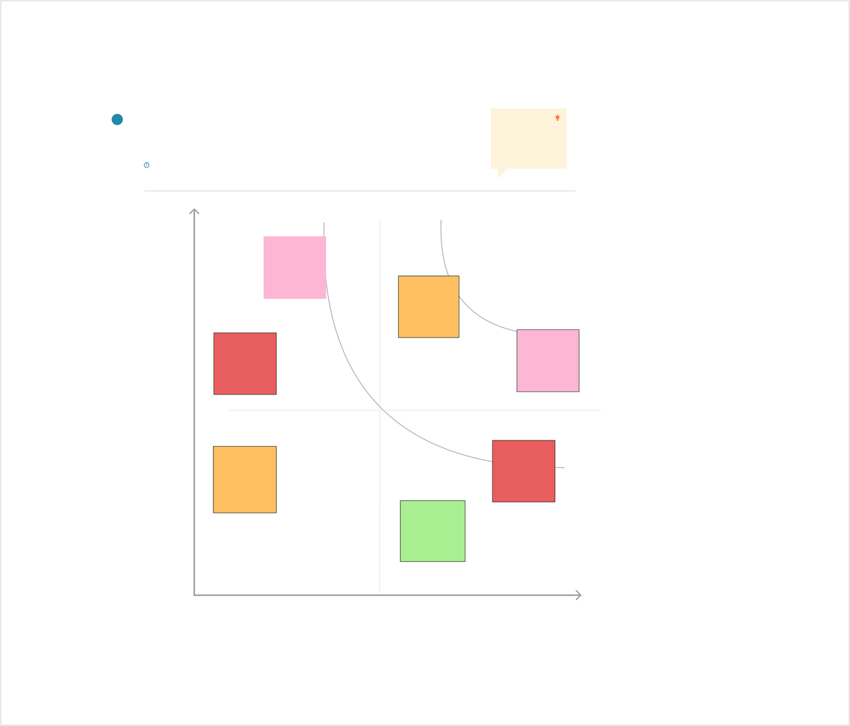
Step-3: Idea Prioritization
Importance
Ifeach of these
tasks could get
done without any
difficulty or cost
,
which would have
the most positive
impact
?

Feasibility
Regardless of their importance
,
which tasks are more
feasible than others
?

(
Cost
,
time
,
effort
,
complexity
,
etc
.)
+
-
-
Raw
material
usage
patterns
+
TIP
Participants can use their
cursors to point at where
sticky notes should go on
the grid
.
The facilitator can
confirm the spot by using
the laser pointer holding the
H key
on the keyboard
.
Prioritize
Your team should all be on the same page about what
'
s important
moving forward
.
Place your ideas on this grid to determine which
ideas are important and which are feasible
.
minutes
20
4
Displaying
best
-
selling
toys

Compare best
sellers month
over month
stocks and
overstock
trends
Repeat vs new
customer
purchases
Average
spending per
customer
Daily
/
weekly
/
monthly sales
trends

